Harp Studio of Melanie Mashner
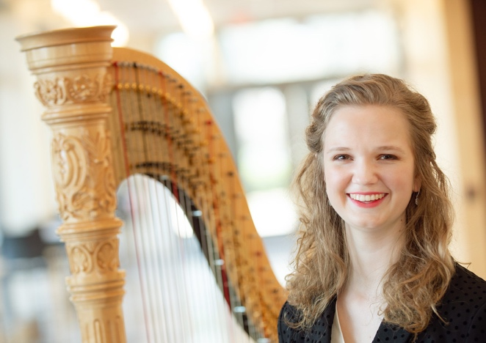
Private Lesson Policies
My role as your teacher is to inspire and encourage my students at any age. Through a balance of technical guidance and encouraging musical expression, we will work on setting goals together to accomplish what is important to you, avoid injury, and reach your potential. Studio policies are designed to create a positive and effective working relationship between student and teacher.
Online Lessons
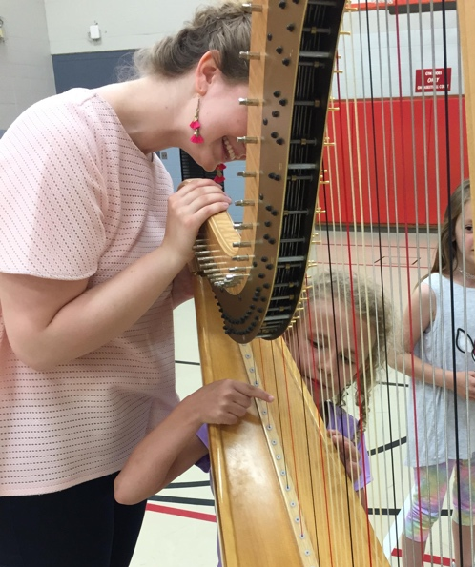
I teach online lessons through Lessonface. Lessonface requires that you have Zoom videoconferencing software downloaded, which is free and easy to use. All payment and scheduling is handled through the Lessonface online portal. You can choose to subscribe for monthly, weekly, or customized bundle lessons.
Attendance
If a student needs to cancel or reschedule a lesson, 24-hour advance notice is required. If an emergency situation occurs within this 24-hour window, I will work with the student on a case-by-case basis, but a refund or reschedule is not guaranteed. In the case of no advanced notice and a missed lesson, I will not issue a refund.
Expectations
Students are expected to be on-time and well prepared for their lessons. Tardiness is deducted from the lesson time and will not be made up. Students are responsible for having their instrument in-tune and strings replaced before the lesson. I may ask students to purchase music books or other materials that I feel are essential to their learning. I recommend ordering materials from Vanderbilt Music Co. and Lyon and Healy Harps.

